Drill Down View

For dimension fields which are part of a hierarchy, you usually need to know the result of analysis for the next or previous level of aggregation. For example, when you know the result for a quarter, you get interested to know the results for each month in that quarter, and you may even need the result for each week. This is a case of drilling down the existing dimensions to get a finer level of granularity.

To drill down and drill up for individual dimension members in a hierarchy, right-click a table header and select Drill Down from the context menu. Consider a bar chart created with the dimension category in the columns shelf and the measure Sales in the Rows shelf. Right-click on the bar representing Furniture and select Drill Down.

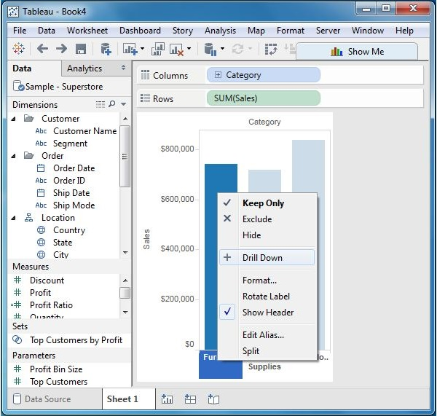

The result of the drill down action is shown in the following screenshot.

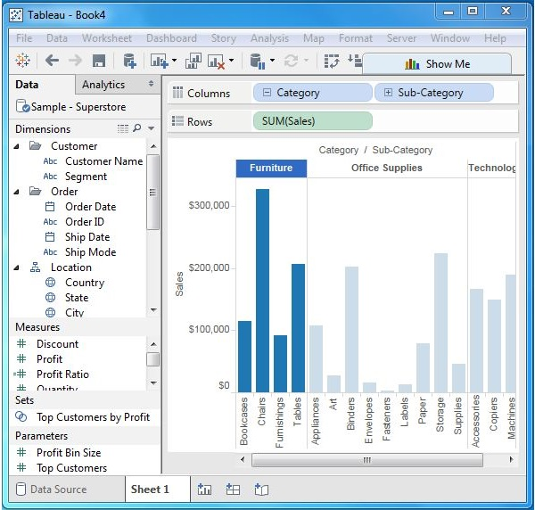

Swapping Dimensions

You can create a new view from an existing view by swapping the position of the dimensions. This does not change the values of the measures, but it does change the position of the measures. Consider a view for analyzing the Profit for each year for each segment and category of products. You can click on the vertical line at the end of category column and drag it to the segment column. This action is shown in the following screenshot.

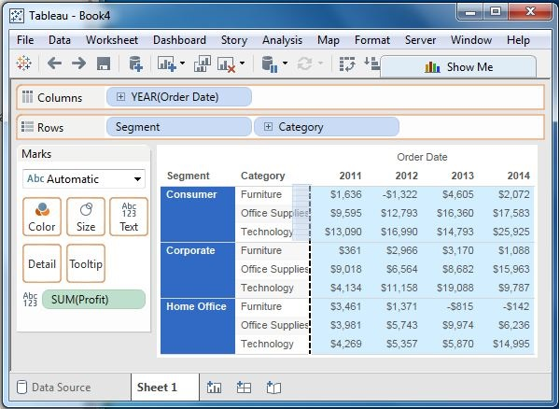

The result of the swapping of the two dimensions is shown in the following screenshot. As you can see, only the position of the values of the measure Profit changes for each category and segment, and not its value.

